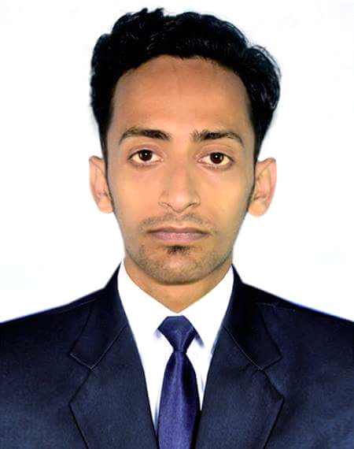

**Sujoy Roy**

E-mail: thrill.live71@gmail.com

Cathlic Mission Road, Srimongol, Moulvibazar

Mobile: +880 1737865099

**Career Objectives:**

To work under a well-recognized organization to communicate and acquire knowledge by keeping touch with people from different environment that will help me to develop an influential personality and determination to earn a grand success.

**Key Skills:**

* Working with various types of peoples, team based culture and deal with different ideas.
* Strong leadership skills and capable to work with multicultural people.
* Ability to motivate teams and employees.

**Educational Background:**

**Masters of Business Administraion (MBA)**

Masters of Business Administration

Present

East West University

Sylhet, Bangladesh.

**Bachelor of Social Science (BSS)**

Bachelor of Social Science (BSS)

Passing Year : 2016

Major in Social Sector

Third Class

Sreemangal Govt.College

National University, Bangladesh.

**Higher Secondary School Certificate (HSC)**

Passing Year : 2010

CGPA : 2.00

Sreemangal Govt. College, Sreemangal

Bangladesh Education Board, Sylhet.

**Secondary School Certificate (SSC)**

Passing Year : 2008

CGPA : 2.75

Victoria High School, Sreemangal

Bangladesh Education Board, Sylhet

**Computer Proficiency:**

MS Word, MS Excel, MS Power Point and familiar with the use of E-mail and Internet Browsing.

**Working Experience:**

**British American Tobacco** (**Asiatic Exp Ltd**.) (November 2019 to Present**)**

* Working as Territory Sales Assistant (TSA) at Kulaura & Rajnogor Point.
* Key Responsibility before & after Sales, Marketing development relevant works of British American Tobacco.
* Overlook Merchandiser activities of Partner & Progoti Channel.

**bKash Limited** (**Market Access Providers Ltd**.) (October 2018 to September 2019**)**

* Working as Trade Merchandising Supervisor (TMS) at Hussain Telecom-1 (South Surma, Sylhet), Gochia Trading (Biyanibazar, Sylhet).
* Responsible for executing official maintenance and other market development related works of bKash Ltd.
* Overlook Merchandiser activities.

**Lava International Bangladesh Limited** (November 2016 to January 2018)

* Working as a Sales Executive (SE) at Lava Smart Phone Sylhet Metro .
* Making a good relationship with Smart Phone Retailer and responsible for market capabilites, increasing marketing growth of sales of Sylhet Metro .

**Language Proficiency:**

I have an excellent command over English and also have a good interpersonal communication skill in Bengali (Native) and English.

**Interest:**

* Participating in Social and Creative work.
* Doing Music as a Vocalist and Musician.
* Hanging with friends in leisure time.
* Composing songs & traveling.

**Extracurricular Activities:**

* President at Sreemangal Band Association (SBA)
* Committee Member at Volunteer for Bangladesh (VBD)
* Vocalist of THRILL, SHLOK, Flames Musical Club.
* Founder Sreemangal Metal Alliance (SMA)
* Executive Member of Volunteer of Bangladesh.
* Vice President of Sylhet Divisional Band Association.

**Personal Information:**

Name : Sujoy Roy

Father’s Name : Sukhendu Roy

Mother’s Name : Sheema Roy

Permanent Address : Cathlic Mission Road, Sreemangal - 3210

Date of Birth : 08thJanuary 1992

Nationality : Bangladeshi

Religion : Sonaton

Marital Status : Single

Blood Group : A+

Contact No : +8801737865099

Email Address : thrill.live71@gmail.com

**Reference:**

Safwat M Rahat Al-Mehdi Muhimin Ovi

Zonal Sales Manager Territory Officer

ShopUp Banglalink Digital Communications, Limited.

Cell : 01401-122167 Cell : 01962-424765

I hereby declare that the information given above is true to the best of my knowledge.

Sincerely Yours,

Sujoy Roy